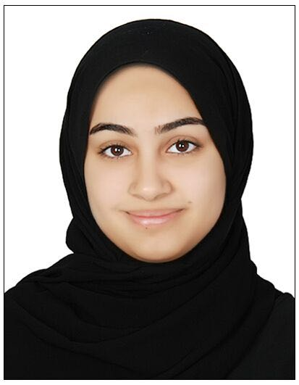

CURRICULUM VITAE OF FATIMA HASSAN AHMED ALI HASSAN.

Home Address: House 3474, Road 4586.Block 745,Area Sanad
Mobile No.:+973 39926688
Email Address: Fa97ty@gmail.com

GENERAL INFORMATION:

Name : Fatima Hassan Ahmed Ali Hassan

Date of Birth : 06 June 1997

Nationality : Bahraini

Marital Status : Married

Passport Details : Passport No.2670522
CPR : 970600909

Driving Lic. : Date of Expiry 26th August, 2020

EDUCATIONAL QUALIFICATION:

Primary 2003-2009 Al Nuwaidrat Girl Primary School

Intermediate 2009-2012 Um Alqura Intermediate School

Secondary 2012-2015 Sitra Secondary Girl school

SKILLS:

- Is able to make decisions and solve problems.
- Is able to effectively and efficiently lead a group.
- Has a good interpersonal and communication skill.
- Has an excellent computer skill especially in MS office Application.
- Knowledge in Information Technology.

Experience :
- Working in Hi dental care as receptionist

PERSONAL TRAITS :

Initiative and work under pressure

Friendly and useful

Powerful and supporter

Patient and work in team

LANGUAGE KNOWN:

Arabic
English

